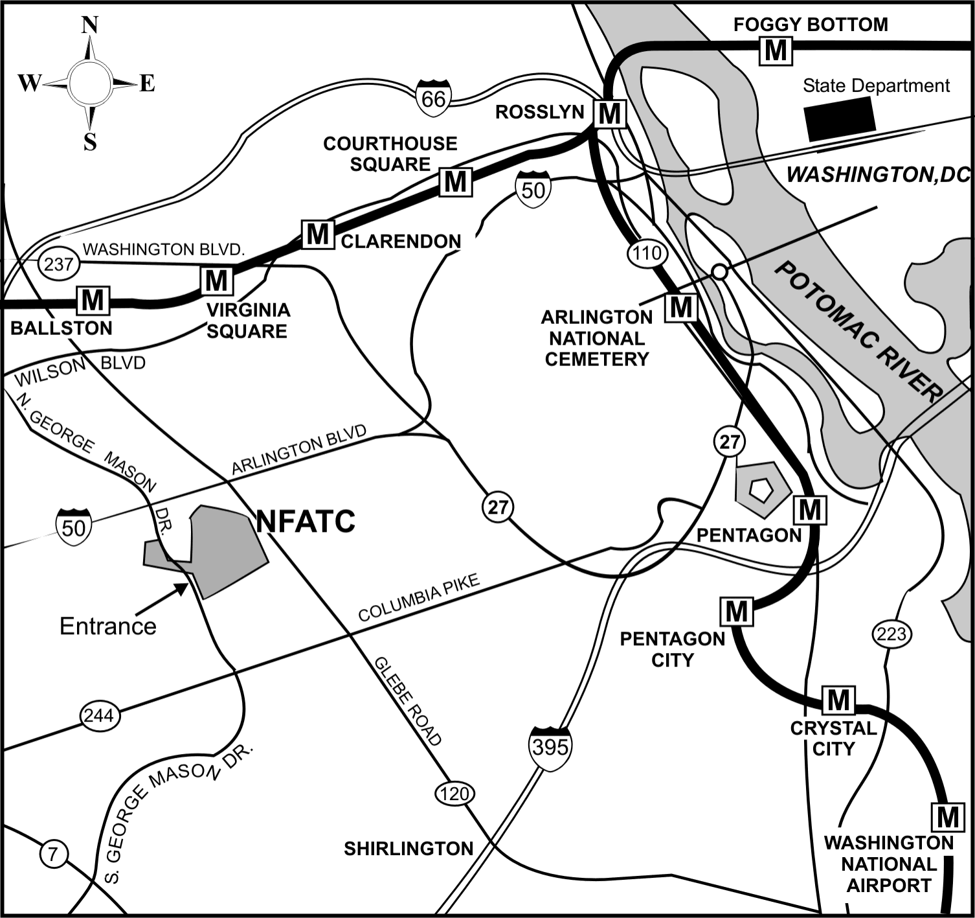
Exit only
NFATC entrance on eastbound Rt. 50 ramp

