“Return from Silence:
China’s Revolutionary Writers”
1982
58 min.

Film by Professor Chung-wen Shih [Shí Zhōngwén 時鐘雯]
The George Washington University

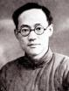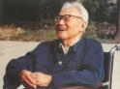
Ba Jin [Bā Jīn 巴金] (Lǐ Fèigān 李芾甘), 25 Nov 1904 – 17 Oct 2005

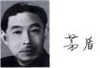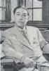
Mao Dun [Máo Dùn 茅盾] (Shĕn Yànbīng 沈雁冰), 04 Jul 1896 - 27 Mar 1981

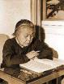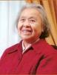
Ding Ling [Dīng Líng 丁玲] (Jiǎng Bīngzhī 蔣冰之), 12 Oct 1904 - 4 Mar 1986

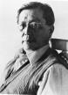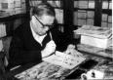
Cao Yu [Cáo Yú 曹禺], 24 Sep 1910 - 13 Dec 1996

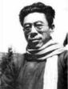
Ai Qing [Aì Qīng 艾青], March 1910 - 5 May 1996

